|  |  |
| --- | --- |
| **Query** | **Report** |
| * **Selecting fields** * **Search criteria** * **Calculated field + formatting** * **Report title** | * **Sort** * **Report header/footer** * **Calculation (count,sum,max,min)** * **Labels for formulas** * **Page orientation** * **Show labels in full** |

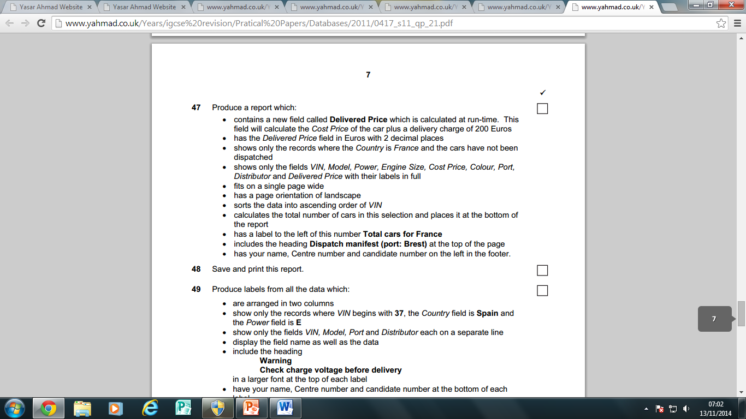

**Search Criteria**

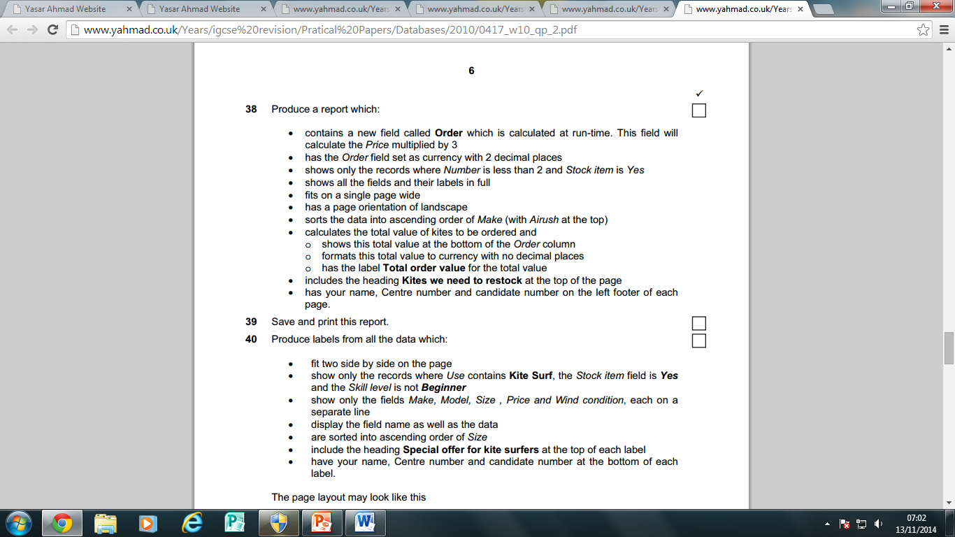

**Search Criteria**

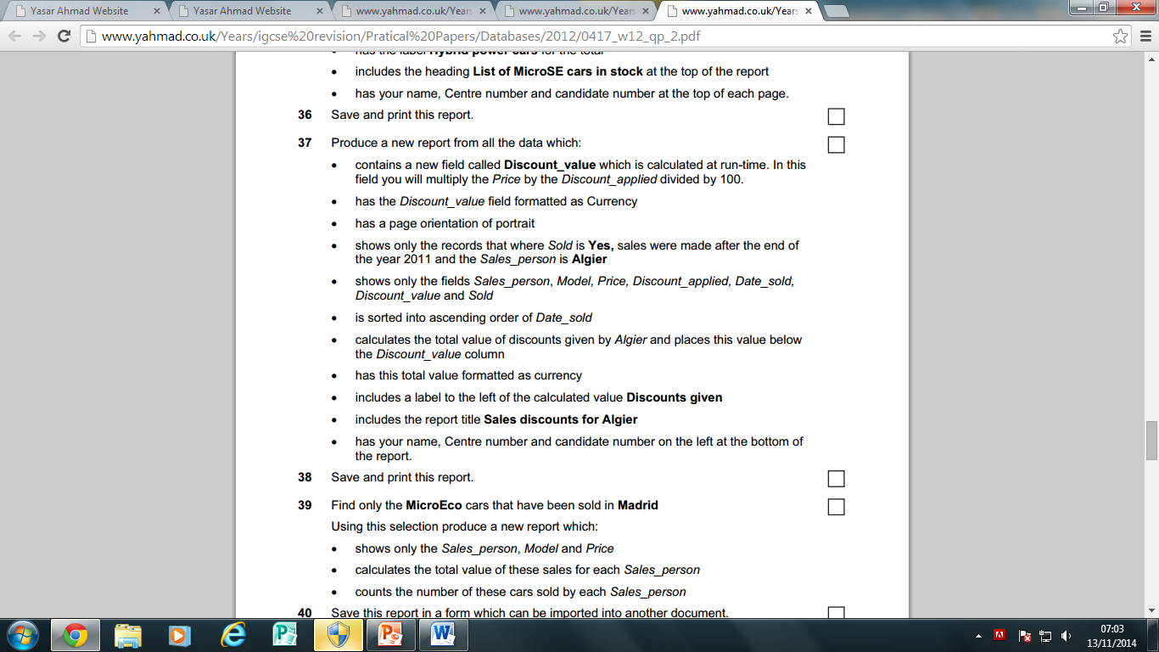

**Search Criteria**

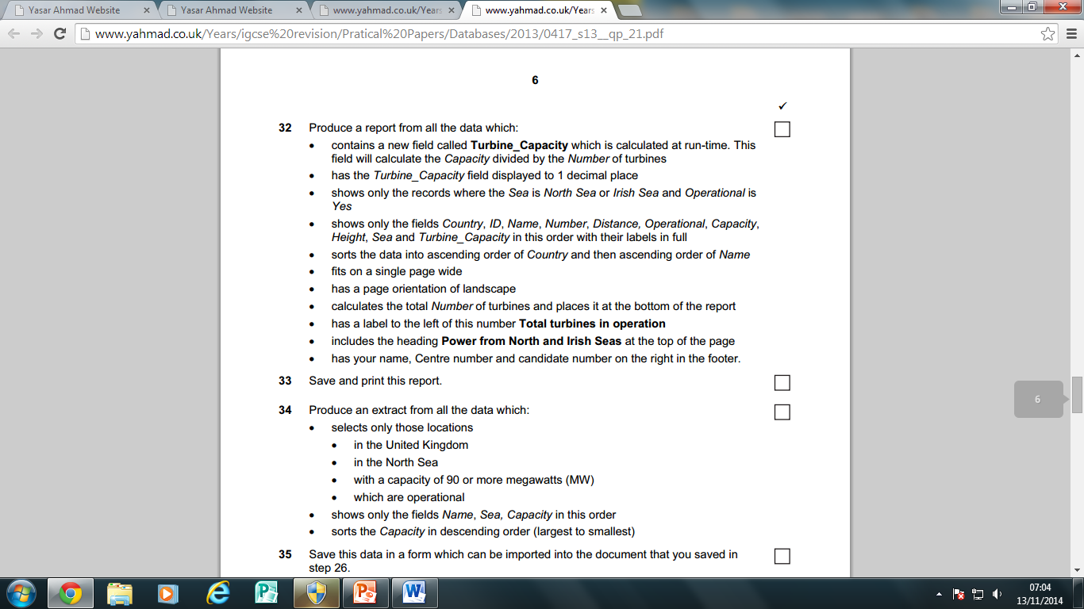

**Search Criteria**